Step 5 - Obedience
To obey God, you must disobey yourself.
3/12/20253 min read
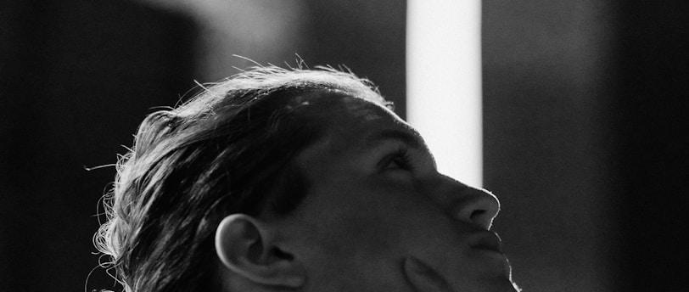

Step 5: Obedience – The Way of the Cross
Key Verse:
"And being found in appearance as a man, He humbled Himself and became obedient to death—even death on a cross" (Philippians 2:8 - NIV)
I recognize that the previous step was challenging. Faith always is. Embracing it as a gift from God and drawing from it the certainty of a way out when we are completely cornered is the privilege of believers. Atheists will simply give up or resign themselves stoically to the imponderable. We, on the other hand, believe in God’s good, perfect, and pleasing will (Romans 12:1) and that He cares for us. Yes, sometimes this step of faith will be taken amid great tribulation. No one said it would be easy. The path is narrow, but it is wide enough for us to walk through it and reach our final destination.
For this to happen and for us to keep walking, we need to learn to take another step: the step of obedience. We briefly mentioned it as a tip to nurture our faith. But obeying is much more than that. God gives us faith and grace so that we can obey Him. When we obey Him, we fulfill the purpose for which we were called. When we said that you had to let go of certain weights in your life to walk, we forgot to mention that there is an instrument of death that you would have to carry with you along this road: the cross.
Jesus is our greatest example of obedience. He, being God, humbled Himself, becoming a man, and was obedient to death—even death on a cross (Philippians 2:8). The cross is the ultimate symbol of obedience. It represents the death of our "self," our selfish desires, and our will independent of God. When we obey God, we disobey someone. Most of the time, ourselves. Our sinful nature will always want to walk a different road. But the Holy Spirit will lead us on the path of Jesus, which is the path of obedience.
What is obedience?
Obedience is the practical response of our faith. It is the act of aligning our will with God’s will, even when it costs us something. Obedience is not a burden but an act of love and trust. Jesus said, "If you love me, you will keep my commandments" (John 14:15).

Why is obedience important?
What is our ultimate goal? To love God above all things! How will it be made real? By obeying his commands, said Jesus (Jo 14:15). Besides, obedience is important because:
- It connects us to God’s purpose: Obedience places us in the center of His will.
- It strengthens our faith: Every act of obedience brings us closer to God and increases our trust in Him.
- It transforms us: Obedience molds us into the image of Christ, who was the ultimate example of submission to the Father.

How to practice obedience?
I know you love our hints to help you in each step. Here are some recommendations to strengthen your battle for obedience.
- Know God’s will: Study the Bible and pray to discern His direction.
- Small steps: Start by obeying in the small things. Faithfulness in little prepares for faithfulness in much (Luke 16:10).
- Depend on the Holy Spirit: He empowers us to obey, even when our flesh resists (Galatians 5:16).
- Persevere: Obedience is not always easy, but it is always worth it.
Practical Example:
Jesus is the greatest example of obedience. He said, "Not my will, but yours be done" (Luke 22:42) in the Garden of Gethsemane, moments before facing the cross. His obedience brought salvation to humanity.
Reflection Question:
"What has God been asking of you that requires an act of obedience, even if it costs you something?"
Final Prayer:
Lord, help me to deny myself, take up my cross, and follow You daily. Give me the grace to obey even when it is hard, trusting that Your will is always the best. Amen.

